OOP LAB 2 REPORT

3.

4.

5.

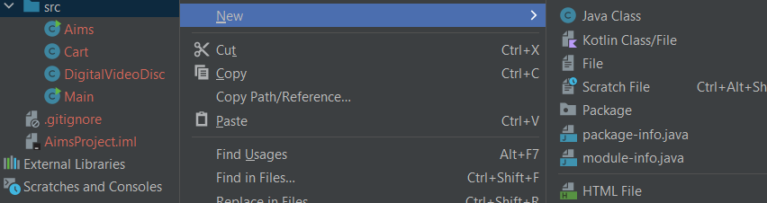

6.

7.

When should accessor methods be used?

8.

- If you create a constructor method to build a DVD by title then create a constructor method to build a DVD by category. Does JAVA allow you to do this?

Answer: No, because category and title have same type String, so JAVA can not distinguish between 2 constructors.

9.

10.

11.

